Project 1: Text Adventure

Alec Nguyen

Abstract

This Text Adventure game is based on choose your own adventure books, the goal is to try and get to the end of the story in various branching pathways. Each decision leads to different outcomes for the user’s game, different locations, areas, items, and interactions within the game.

If the player character dies at any point in the game they lose and must restart from the beginning, and must either learn from their mistakes, choose different options or even have luck on their side when making decisions.

# Summary

Project Size: 586 lines of code

Number of variables used: 12

This project uses all the methods learned in class and the book up to this point in the class schedule. User defined functions and various loops, and switch statements are what drives this game to work.

This project took about a week to complete and debug making sure all potential scenarios worked with the different variables in the game. It was fun writing the game because I was able to add some humor instead of making it a generic fantasy setting.

## Pseudo Code.

*Initialize*

*User enters name*

*Introduction to game*

*User selects ‘weapon’*

*User Selects path*

*Goes to Inn*

*User makes decision*

*User buys a room*

*User goes to castle*

*User wins or loses based on decisions*

*Goes to Forest*

*Interaction with a character*

*User dies*

*User lives*

*Goes to valley*

*Interaction with character*

*User dies*

*User advances to castle*

*User wins or loses based on decisions*

*Idle*

*User dies*

Flow-Charts. 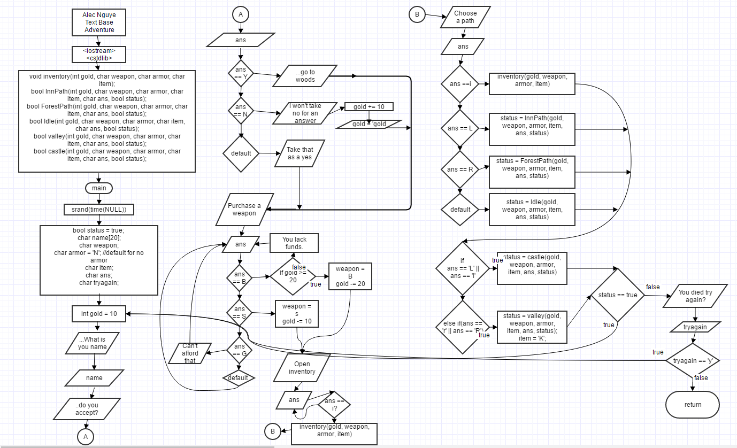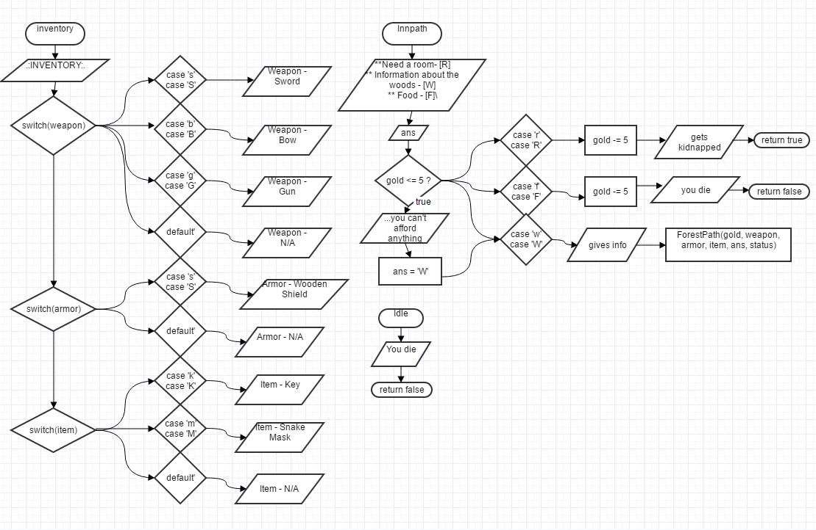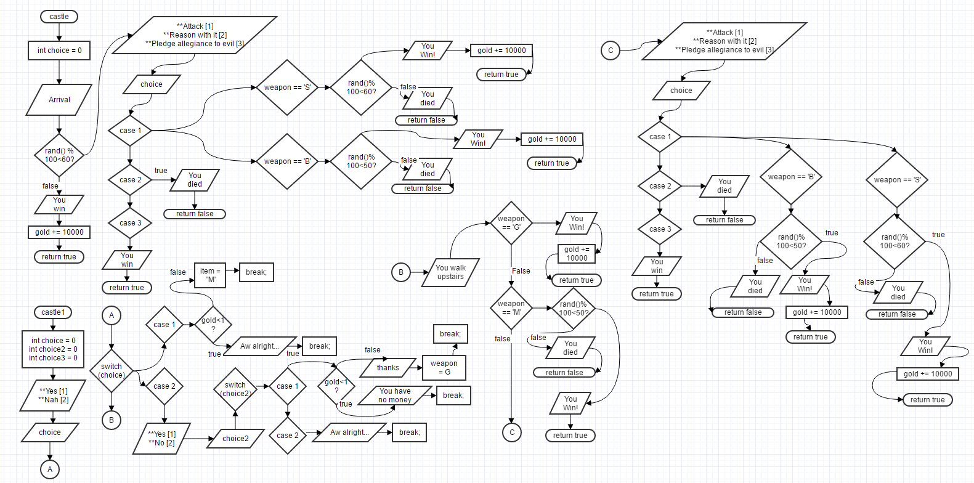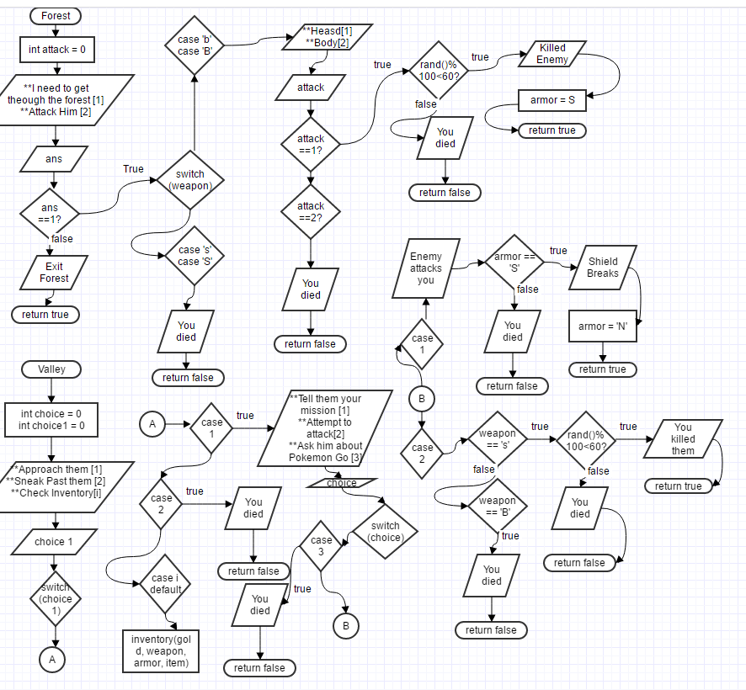

*\*Full size diagrams included in project folder*

Major Variables.

|  |  |  |  |
| --- | --- | --- | --- |
| Type | Variable Name | Description | Location |
| Interger | gold | The amount of gold the player has. | int main()  void inventory()  bool InnPath()  bool ForestPath()  bool Idle()  bool valley()  bool castle()  bool castle1() |
|  | attack | Attack choice | bool ForestPath() |
|  | choice | User choice in various functions. | bool valley()  bool castle()  bool castle1() |
|  | choice1 | User choice in various functions. | bool valley() |
|  | choice2 | User choice in various functions. | bool castle1() |
|  | choice3 | User choice in various functions. | bool castle1() |
| Bool | status | If status is true the player is alive and false if dead. | int main()  bool InnPath()  bool ForestPath()  bool Idle()  bool valley()  bool castle()  bool castle1() |
| char | name[20] | User inputted name | int main() |
|  | weapon | Player weapon, weapon is changed based on player decisions. | int main()  void inventory()  bool InnPath()  bool ForestPath()  bool Idle()  bool valley()  bool castle()  bool castle1() |
|  | armor | Player armor, is changed based on player decisions. | int main()  void inventory()  bool InnPath()  bool ForestPath()  bool Idle()  bool valley()  bool castle()  bool castle1() |
|  | item | Player item, is changed based on player decisions. | int main()  void inventory()  bool InnPath()  bool ForestPath()  bool Idle()  bool valley()  bool castle()  bool castle1() |
|  | ans | Response when prompted a question in game. | int main()  void inventory()  bool InnPath()  bool ForestPath()  bool Idle()  bool valley()  bool castle()  bool castle1() |
|  | tryagain | Prompts user to restart the game. | int main() |

**C++ Constructs**.

|  |  |
| --- | --- |
| Contruct | Location |
| srand(time(NULL)) | int main() |
| Array | name[20] |
| do-while loops | int main() |
| switch statements | int main()  void inventory()  bool InnPath()  bool ForestPath()  bool Idle()  bool valley()  bool castle()  bool castle1() |
| if/else it/else statements | int main()  void inventory()  bool InnPath()  bool ForestPath()  bool Idle()  bool valley()  bool castle()  bool castle1() |
| rand() | bool ForestPath()  bool castle()  bool castle1() |
| User defined functions | source code |

**Source Code.**

/*

* File: main.cpp

* Author: Alec Nguyen

* Date: July 16, 2016

* Purpose: Text Based Adventure

* Created on July 16, 2016, 5:13 PM

*/

//system libraries

#include <iostream>//Input/Output Library

#include <cstdlib>

using namespace std;//Namespace of the System Libraries

//User Libraries (Libraries created by the user)

//Global Constants

//Function Prototypes

void inventory(int gold, char weapon, char armor, char item);

bool InnPath(int gold, char weapon, char armor, char item, char ans, bool status);

bool ForestPath(int gold, char weapon, char armor, char item, char ans, bool status);

bool Idle(int gold, char weapon, char armor, char item, char ans, bool status);

bool valley(int gold, char weapon, char armor, char item, char ans, bool status);

bool castle(int gold, char weapon, char armor, char item, char ans, bool status);

bool castle1(int gold, char weapon, char armor, char item, char ans, bool status);

//Execution Begins Here!

int main(int argc, char** argv) {

srand(time(NULL));

//Declare Variables

bool status = true; //Status either true(alive) or false(dead), if you die the adventure ends

char name[20];

char weapon;

char armor = 'N'; //default for no armor

char item;

char ans;

char tryagain;

do{

do{

int gold = 10;

//Enter Name

cout<<"Welcome to, uh I don't know something generic and fantasy sounding, Farlandia.\n";

cout<<"What is your name?\n";

cin>>name;

//Accept Mission

cout<<"\nWow you're parents settled for that, really? Well alright. Hello Sir "<<name<<".\n";

cout<<"Your mission today is to go to that ominous abandoned castle way over,\n";

cout<<"you know the one past the haunted forest, through the monster filled valley,\n";

cout<<"on top of the highest mountain in the land? Well that dragon or witch or whatever captured her\n";

cout<<"(again, yes I know) and you've got to go save her, do you accept? [Y/N]\n";

cin>>ans;

switch(ans){

case 'y':

case 'Y':

cout<<"Great take the main path out of town into the woods.\n";

break;

case 'N':

case 'n':

cout<<"I won't take no for an answer, here's a couple coins to boost your\n";

cout<<"confidence.\n";

gold += 10;

cout<<"**Gold = "<<gold<<endl;

break;

default:

cout<<"...Err not exactly sure what you just said but I'll take it as a yes.\n";

}

//Buy Weapon

cout<<"\nBefore we go off we need to get you a weapon to defend yourself with.\n";

cout<<"**You walk to the nearest store with "<<gold<<"g in your pockets.**\n";

cout<<"**You see the shopkeeper, a sword [10g], a bow and arrow[20g], and a gun [1000g]**\n";

cout<<"**To purchase enter S - sword, B - bow, G - gun**\n";

cin>>ans;

switch(ans){

case's':

case'S':

if(gold >= 10){

cout<<"\"Careful, that thing is pointy\"\n\t-Shopkeeper\n";

weapon = 'S';

gold -= 10;

cout<<"**Gold = "<<gold<<endl;

}

break;

case 'B':

case 'b':

if(gold >= 20){

cout<<"\"Watch where you aim that thing!\"\n\t-Shopkeeper\n";

weapon = 'B';

gold -= 20;

cout<<"**Gold = "<<gold<<endl;

}else{

cout<<"\"With what money are you trying to buy that with?? Here take this sword instead.\"\n\t -Shopkeeper\n";

weapon = 'S';

gold -= 10;

cout<<"**Gold = "<<gold<<endl;

}

break;

case 'g':

case 'G':

cout<<"\"...Yeah no, and don't bother asking me where I got that either. Look at something you can afford instead.\"\n\t-Shopkeeper\n";

cin>>ans;

default:

cout<<"\"Do you speak English dude?\"\n\t-Shopkeeper\n";

cout<<"**To purchase enter S - sword, B - bow, G - gun**\n";

}

//Check Inventory

cout<<"\nGreat purchase, if you want to check you inventory all you have to do is enter \"I\"\n";

cout<<"at any time now.\n";

cout<<"Try it now.\n";

cin>>ans;

switch(ans){

case 'i':

case 'I':

inventory(gold, weapon, armor, item);

break;

default:

cout<<"Try it again enter \"I\"."<<endl;

cin>>ans;

}

//Forest 1

cout<<"\nAlright let's roll.\n";

cout<<"You enter the main path out of town into the haunted woods, after a couple\n";

cout<<"of hours you reach a fork in the road, there is sign. It reads:\n";

cout<<"** Go left for the inn\n";

cout<<"** Go right to continue through the woods\n";

cout<<"** Enter [L/R] to pick a path\n";

cin>>ans;

switch(ans){

case 'i':

case 'I':

inventory(gold, weapon, armor, item);

break;

case 'l':

case 'L':

status = InnPath(gold, weapon, armor, item, ans, status);

break;

case 'r':

case 'R':

status = ForestPath(gold, weapon, armor, item, ans, status);

break;

default:

status = Idle(gold, weapon, armor, item, ans, status);

}

if(ans == 'L' || ans == 'l'){

status = castle(gold, weapon, armor, item, ans, status);

}else if(ans == 'r' || ans == 'R'){

status = valley(gold, weapon, armor, item, ans, status);

item = 'K';

}

//Process the Data

//Output the processed Data

}while(status == true);

cout<<"\nLooks like you died! Well that sucks. Try again? [Y/N]\n";

cin>>tryagain;

cout<<endl;

}while(tryagain == 'Y' || tryagain == 'y');

//Exit Stage Stage!

return 0;

}

void inventory(int gold, char weapon, char armor, char item){

cout<<endl;

cout<<".:INVENTORY:.\n";

cout<<gold<<"g"<<endl;

switch(weapon){

case 'S':

case 's':

cout<<"Weapon - Sword"<<endl;

break;

case 'B':

case 'b':

cout<<"Weapon - Bow"<<endl;

break;

case 'G':

case 'g':

cout<<"Weapon - Gun"<<endl;

break;

default:

cout<<"Weapon - N/A"<<endl;

}

switch(armor){

case 'S':

case 's':

cout<<"Armor - Wooden Shield"<<endl;

default:

cout<<"Armor - N/A"<<endl;

}

switch(item){

case 'K':

case 'k':

cout<<"Item - Key"<<endl;

case 'M':

case 'm':

cout<<"Item - Snakeman Mask"<<endl;

default:

cout<<"Item - N/A"<<endl;

}

}

bool InnPath(int gold, char weapon, char armor, char item, char ans, bool status){

cout<<"\nYou enter the inn, it's barren inside and could use a good dusting. At the bar \n";

cout<<"is the innkeeper mindlessly wiping down the a glass and he notices you walk.\n";

cout<<"\"How's it going traveler what do you need? A room to stay[5g]? Something to eat[5g]?\"\n\t-Innkeeper\n";

cout<<"** Need a room- [R]\n";

cout<<"** Information about the woods - [W]\n";

cout<<"** Food - [F]\n";

cin>>ans;

if(gold <= 5){

cout<<"Looks like you can't afford anything, probably best to ask for information instead.\n";

ans = 'W';

}

switch(ans){

case 'R':

case 'r':

gold -= 5;

cout<<"**Gold = "<<gold<<endl;

cout<<"\"Alright here's the room it's the first door on the left\"\n\t-Innkeeper\n";

cout<<"You step into the bed, the sheets are damp and there's spidervwebs covering the ceiling.\n";

cout<<"It's comfier than a walk through the woods though, so you fall asleep regardless.\n";

cout<<"..........\n";

cout<<"..........\n";

cout<<".......*CRASH*.*BOOM*.....\n";

cout<<"Oh no! Looks like the Inn has been raided judging by that black sack over your head and the \n";

cout<<"dead innkeeper. And they're throwing you on the back of their horse.\n";

return true;

case 'F':

case 'f':

gold -= 5;

cout<<"**Gold = "<<gold<<endl;

cout<<"**The Innkeeper hands you a delicious looking pie and candy bar, which you eat promptly.\n";

cout<<"...\n";

cout<<"Oh no! The food was undercooked. You've contracted a fatal stomach parasite.\n";

cout<<"Death by candybar\n";

return false;

case 'W':

case 'w':

default :

cout<<"\"Well let me tell you that while these woods are haunted the spirit that protects them certainly will not\n";

cout<<"harm you unless provoked.\"\n\t-Innkeeper\n";

cout<<"You leave the inn and back to the fork in the woods, and deeper into the forest.\n";

ForestPath(gold, weapon, armor, item, ans, status);

}

}

bool ForestPath(int gold, char weapon, char armor, char item, char ans, bool status){

int attack = 0;

cout<<"\nContinuing into the forest soon the tree line blocks out the sun, and suddenly in front of\n";

cout<<"you stand the guardian spirit of the forest, a ghostly figure shrouded in plant matter and thick tree bark.\n";

cout<<"\"'Sup dude what you need?\"\n\t-Forest Spirit\n";

cout<<"**I need to get through the forest [1]\n";

cout<<"**Attack him [2]\n";

cin>>ans;

if(ans == 1){

cout<<"Oh your gonna go up to the castle, and save the princess and kill that evil guy?\n";

cout<<"Sure I can get behind that 'lemme just summon a moose you can ride that bad boy all\n";

cout<<"the way through the forest no problem. Good Luck!\n";

return true;

}else{

switch(weapon){

case 's':

case 'S':

cout<<"You pull out your sword and swing at the spirit and he is unphased.\n";

cout<<"\"You're a real jerk you know that?\"\n\t-Forest Spirit\n";

cout<<"Suddenly the roots of the trees surrounding you squeezing the life out of you, great job\n";

cout<<"pissing off the supernatural spirits.\n";

return false;

case 'B':

case 'b':

cout<<"You pull out you bow and take aim. Where do you shoot?\n";

cout<<"** Head [1]\n";

cout<<"** Body [2]\n";

cin>>attack;

if(attack == 1){

if(rand() % 100 < 60){//60% random chance you kill him

cout<<"**Your arrow pierces the spirits head, as he withers away so does all life around you.\n";

cout<<"Uh good job, at least the forest path is cleared and maybe the town back home can finally\n";

cout<<"go forward with building that mall and parking structure. ...Wait what are you doing? \n";

cout<<"Oh that's so gross why are you really taking his tree bark and making a shield c'mon you\n";

cout<<"just shot the guy in the face.\n";

armor = 'S';

cout<<"Armor - Wooden Shield"<<endl;

return true;

}else{

cout<<"You release the arrow and it misses.\n";

cout<<"\"You're a real jerk you know that?\"\n\t-Forest Spirit\n";

cout<<"Suddenly the roots of the trees surrounding you squeezing the life out of you, great job\n";

cout<<"pissing off the supernatural spirits.\n";

return false;

}

}else if(attack == 2){

cout<<"You release the arrow at the Spirit's chest and he is unphased by the arrow.\n";

cout<<"\"You're a real jerk you know that?\"\n\t-Forest Spirit\n";

cout<<"Suddenly the roots of the trees surrounding you squeezing the life out of you, great job\n";

cout<<"pissing off the supernatural spirits.\n";

return false;

}

}

}

}

bool Idle(int gold, char weapon, char armor, char item, char ans, bool status){

cout<<"\nWhile standing by idly, a bandit thats been following you since you left town \n";

cout<<"finally takes his chance and sticks you in the back of the neck with his knife and takes you belongings\n";

cout<<"leaving you on the side of the road.\n";

cout<<"What an anticlimactic ending.\n";

return false;

}

bool valley(int gold, char weapon, char armor, char item, char ans, bool status){

int choice = 0;

int choice1 = 0;

cout<<"\nHere we are through the valley of the shadow of death about halfway to the castle.\n";

cout<<"What's that over there in the distance? It looks like a gang of, uhhhhhhhh snakemen!,\n";

cout<<"The same half-man, half-snake bipedal minions of the one who took the princess to the tower.\n";

cout<<"How should we deal with this situation?\n";

cout<<"**Approach them - [1]\n";

cout<<"**Sneak past them - [2]\n";

cout<<"**Check Inventory - [i]\n";

cin>>choice1;

switch(choice1){

case 1:

cout<<"Really. This should be good.\n";

cout<<"As you walk closer to their camp one of the snakemen notices you and motions to the others.\n";

cout<<"Their leader emerges from a tent at least a head taller than the rest.\n";

cout<<"\"The name'ssss Cobrakai. Whatsss are you doing here littlesss mansss\"\n\t-Cobrakai\n";

cout<<"**Tell them you mission -[1]\n";

cout<<"**Attempt to attack Cobrakai - [2]\n";

cout<<"**Ask him about Pokemon Go - [3]\n";

cin>>choice;

switch(choice){

case 1:

cout<<"\"Well I'm not sssure why you just told us your planss but we are here to stop anyone attempting to take the princesssss\"\n";

cout<<"Man that hissing thing is real annoying\n";

cout<<"Cobrakai lunges towards you.\n";

if(armor == 'S' || armor == 's'){

cout<<"You raise your shield and and his fangs get stuck in the shield and he turns into wood himself\n";

cout<<"**Your shield breaks\n";

armor = 'N';

cout<<"All the other snake dudes are struck with fear and let you pass\n";

cout<<"The snakemen offer you the key to the castle out of fear.\n";

return true;

}else{

cout<<"With nothing to protect you Cobrakai procedes to bite your head off.\n";

cout<<"You dead.\n";

return false;

}

break;

case 2:

if(weapon == 'S' || weapon == 's'){

if(rand() % 100 < 60){//60% Success Rate

cout<<"You close your eyes and wildly swing your sword around for a good three and a half minutes.\n";

cout<<"When you open you eyes you see that you've miraculously killed all the snakemen with ease.\n";

cout<<"You loot the snakemens' camp and find a key marked \"Key to Castle\", how convenient?\n";

return true;

}else{

cout<<"You wildly swing you sword around, but fail to hit any of the snakemen, as a result they all bite your head off.\n";

return false;

}

}

if(weapon == 'B' || weapon == 'b'){

cout<<"You are too slow on the draw and the snakemen kill you.\n";

cout<<"You're dead.\n";

return false;

}

break;

case 3:

cout<<"\"That doesssn't even exissst in thisss universsse.\"\n";

cout<<"Cobrakai lunges towards you can bites your head off.\n";

cout<<"Sssuch a tragedysss, sssorry too sssoon?\n";

return false;

break;

case 'I':

case 'i':

inventory(gold, weapon, armor, item);

break;

default:

cout<<"\"You're insesssent and incoherent babbling annoysss me\"\n";

cout<<"Cobrakai lunges towards you can bties your head off.\n";

cout<<"Sssuch a tragedysss, sssorry too sssoon?\n";

return false;

}

break;

case 2:

cout<<"You wait until it's dark out and start to shimmy along the valley wall hoping that the snakemen don't notice\n";

cout<<"you, unfortunately you forgot that snakeman have night vision";

cout<<"You dead.\n";

return false;

break;

case 'I':

case 'i':

default :

inventory(gold, weapon, armor, item);

break;

}

}

bool castle(int gold, char weapon, char armor, char item, char ans, bool status){

int choice = 0;

cout<<"**Hours later and bucket of water splashed on your face\n";

cout<<"**You open you eyes and see the evil ";

if (rand() % 100 < 60){

cout<<"Dragon! You were incredibly ill equipped for this moment.\n";

cout<<"What should you do?\n";

cout<<"**Attack - [1]\n";

cout<<"**Reason with it - [2]\n";

cout<<"**Pledge allegiance to evil - [3]\n";

cin>>choice;

switch(choice){

case 1:

if(weapon == 'S' || weapon == 's'){

if(rand() % 100 < 60){

cout<<"And a SWING... and a miss\n";

cout<<"The Dragon picks you up with his claws and flings you out the window, this won't end well you know.\n";

cout<<"**Splat**\n";

return false;

}else{

cout<<"And a SWING... hey look you blinded him with your sword didn't know you had it in you.\n";

cout<<"The Dragon flails around wildly smashing into the walls of the castle.\n";

cout<<"You quickly grab the Princess and the Dragon's gold, Congrats you win!\n\n";

cout<<".:OBTAINED:."<<endl;

gold += 10000;

cout<<gold<<"g"<<endl;

return true;

}

}

if(weapon == 'B' || weapon == 'b'){

if(rand() % 100 < 50){

cout<<"You quickly draw your bow and fire as quickly as possible, huh didn't know you had it in you.\n";

cout<<"The Dragon flails around wildly smashing into the walls of the castle.\n";

cout<<"You quickly grab the Princess and the Dragon's gold, Congrats you win!\n\n";

cout<<".:OBTAINED:."<<endl;

gold += 10000;

cout<<gold<<"g"<<endl;

return true;

}else{

cout<<"You missed every single shot? I should recruited that other random guy in town to do this job\n";

cout<<"The Dragon opens it's mouth and burns to to ash.\n";

cout<<"... and he takes your money.\n";

cout<<".:LOST:."<<endl;

gold -= gold;

cout<<gold<<"g"<<endl;

return false;

}

}

break;

case 2:

cout<<"Dragons don't english dummy, he eats you.\n";

return false;

break;

case 3:

cout<<"What the hell man, what am I supposed to tell the village and King.\n";

cout<<"Alright enjoy living in this dusty tower with your dragon friend you jerk.\n";

return true;

break;

}

}else{

cout<<"...wait a second nobodies home, uh I guess we're late. Hey look Dragon's gold let's loot that and we'll count that as a win!\n";

cout<<".:OBTAINED:."<<endl;

gold += 10000;

cout<<gold<<"g"<<endl;

cout<<"\n**You Win!**\n";

return true;

}

}

bool castle1(int gold, char weapon, char armor, char item, char ans, bool status){

int choice = 0;

int choice2 = 0;

int choice3 = 0;

cout<<"You approach the castle and unlock the gates with the key.\n";

cout<<"The grounds are empty, so you enter the keep. The keep is empty but filthy with garbage and\n";

cout<<"mugs of beer on the ground, over in the corner you see the shopkeeper still obviously drunk.\n";

cout<<"\"Oh, you're the dude from town. Listen there was a crazy party here last night and some wench snatched my wallet.\n";

cout<<"You think you could spare some change and call me an Uber [-1g]?\"\n\t-Shopkeeper\n";

cout<<"**Yes - [1]\n";

cout<<"**Nah - [2]\n";

cout<<gold<<"g"<<endl;

cin>>choice;

switch(choice){

case 1:

if(gold < 1){

cout<<"\"On second thought maybe I'll just walk home good luck with the dragon upstairs.\"\n";

break;

}else{

cout<<"\"Awesome, here take this snakeman mask, if the Dragon upstairs isn't paying attention you\n";

cout<<"should be able to sneak by real quick\"\n";

item = 'M';

cout<<".:OBTAINED:."<<endl;

cout<<"Item - Snakeman Mask"<<endl;

break;

}

break;

case 2:

cout<<"\"Tell you what buy me the Uber and I'll give you this gun, deal?\"\n";

cout<<"**Yes -[1]\n";

cout<<"**No - [2]\n";

cin>>choice2;

switch(choice2){

case 1:

if(gold < 1){

cout<<"\"Looks like you have no money. On second thought maybe I'll just walk home good luck with the dragon upstairs.\"\n";

break;

}else{

cout<<"\"Awesome you're a life-saver. Also don't ask where I got that gun.\"\n";

weapon = 'G';

cout<<".:OBTAINED:."<<endl;

cout<<"Weapon - Gun"<<endl;

break;

}

case 2:

cout<<"\"Aw alright fine, I'll walk.\"\n";

break;

}

}

cout<<"You walk upstairs into the dragon's lair.\n";

if(weapon == 'G'){

cout<<"Without any planning or thought you kick down the door guns blazing.\n";

cout<<"The dragon is killed before he even realizes you are there.\n";

cout<<"You collect the princess and the dragon's gold, You win!\n";

cout<<".:OBTAINED:."<<endl;

gold += 10000;

cout<<gold<<"g"<<endl;

return true;

}else if(item == 'M'){

cout<<"You walk in wearing the mask hoping the Dragon doesn't notice you.\n";

if(rand() % 100 < 50){

cout<<"The dragon turns and sees you but pays no attention to you, it worked!\n";

cout<<"You snatch up the princess and get out of there as fast as possible you win!\n";

return true;

}else{

cout<<"The dragon sees you immediately and doesn't buy into the costume.\n";

cout<<"He eats you, you're dead. You lose.\n";

return false;

}

}else{

cout<<"You were incredibly ill equipped for this moment.\n";

cout<<"What should you do?\n";

cout<<"**Attack - [1]\n";

cout<<"**Reason with it - [2]\n";

cout<<"**Pledge allegiance to evil - [3]\n";

cin>>choice;

switch(choice){

case 1:

if(weapon == 'S' || weapon == 's'){

if(rand() % 100 < 60){

cout<<"And a SWING... and a miss\n";

cout<<"The Dragon picks you up with his claws and flings you out the window, this won't end well you know.\n";

cout<<"**Splat**\n";

return false;

}else{

cout<<"And a SWING... hey look you blinded him with your sword didn't know you had it in you.\n";

cout<<"The Dragon flails around wildly smashing into the walls of the castle.\n";

cout<<"You quickly grab the Princess and the Dragon's gold, Congrats you win!\n\n";

cout<<".:OBTAINED:."<<endl;

gold += 10000;

cout<<gold<<"g"<<endl;

return true;

}

}

if(weapon == 'B' || weapon == 'b'){

if(rand() % 100 < 50){

cout<<"You quickly draw your bow and fire as quickly as possible, huh didn't know you had it in you.\n";

cout<<"The Dragon flails around wildly smashing into the walls of the castle.\n";

cout<<"You quickly grab the Princess and the Dragon's gold, Congrats you win!\n\n";

cout<<".:OBTAINED:."<<endl;

gold += 10000;

cout<<gold<<"g"<<endl;

return true;

}else{

cout<<"You missed every single shot? I should recruited that other random guy in town to do this job\n";

cout<<"The Dragon opens it's mouth and burns to to ash.\n";

cout<<"... and he takes your money.\n";

cout<<".:LOST:."<<endl;

gold -= gold;

cout<<gold<<"g"<<endl;

return false;

}

}

break;

case 2:

cout<<"Dragons don't english dummy, he eats you.\n";

return false;

break;

case 3:

cout<<"What the hell man, what am I supposed to tell the village and King.\n";

cout<<"Alright enjoy living in this dusty tower with your dragon friend you jerk.\n";

return true;

break;

}

}

}

References

Savitch, Walter. *Problem Solving with C++*. 7th ed. Boston: Pearson Education, 2009. Print.